# **Course Introduction**

## Introduction to HTML and CSS in depth

n/a

## How are HTML and CSS used in the real world?

*The combination of HTML and CSS has meant that web browsing can be done on a variety of devices and not just computers and phones. Which of the following statements about CSS are true? Select all that apply.*

* *You can change a web page's appearance with CSS without editing its HTML.*
* *CSS describes the look and layout of a document written in HTML.*
* *CSS gives you control over spacing and positioning of content on a web page.*

## Recap: What you know about HTML and CSS

*HTML is foundational to websites and there is a lot that you can do with it. Which of the following are you able to do with HTML? Check all that apply.*

* *You can display data in tables with HTML.*
* *You can build forms with HTML.*
* *You can add images to a web page with HTML.*

# **Semantic and Meta tags**

## Semantic tags and why we need them

*Semantic tags describe the meaning of a web page and they help search engines and accessibility software like screen readers to understand the contents of a page. Which of the following statements are true? Choose all that apply.*

* *Basic HTML tags like the heading and list tags can be used to describe content.*
* *The article element is used for complete, self-contained compositions on a web page.*
* *The main navigation links of your website should be added inside the nav element.*

## Semantic tags in action

*Is the following statement true or false? If you want to create an unordered list you should use the li tag.*

* *False*

## Metadata

Meta tags define metadata about a web page. What is metadata? You ask? It's data about other data which in this case is data about the web page. Meta tags are added inside the head element of your html document and as you know, nothing inside the head element is displayed in the web browser. In other words, meta tags are unseen elements within the browser.

The name attribute specifies the name of the metadata and the content attribute specifies the value of the metadata.

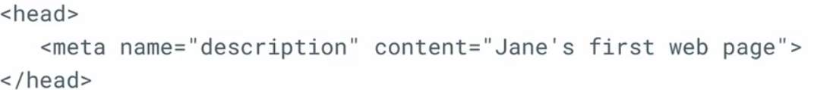

*You want to improve the SEO of a website. What metadata should you add to the head element of the website and why? Check all that apply.*

* *Robots metadata to improve how search engines analyze the website.*
* *Description metadata to help search engines understand what the web page is about.*
* *Author metadata to inform search engines who the author of the web page is.*
* *Viewport data to help web browsers display websites at the appropriate scale on the device being used.*

## Bare bones layout

*When adding a new CSS and a new JavaScript file to the template web page, what needs to be done? Check all that apply.*

* *Add a script element to reference the JS file*
* *Add a link element to reference the CSS file*
* *Add the CSS file to the css folder*
* *Add the JavaScript file to the js folder*

## UX with meta tags

When you share a link, most social networks generate a preview of the link to let users know what the linked webpage is about.

Traditional SEO Meta tags are oriented towards search results, not direct links.

Facebook's rapid growth led to millions of people sharing thousands of links every day. To improve the user experience, they had to find a way to display information about a website before a user clicks on the link. To address this challenge, Facebook established the Open Graph Protocol in 2010. The Open Graph Protocol is a set of Metadata rules that allow web pages to describe themselves to social networks.

*Frontend developers use the Open Graph Protocol to improve the user experience of shared links because it helps social media platforms create a preview of the shared web page.*

* *Yes*

The Open Graph Protocol requires that you must always include four properties on a webpage. These are title, type, URL, and image.

## Setting up a social media card

*As part of your role as a developer you've been asked to prepare a web page so it can be linked on social media platforms. Which of the following statements are true? Choose all that apply.*

* *A meta tag can determine what title will be displayed in the preview of a website on a social media platform.*
* *A meta tag can inform social media platforms of the content type such as video or website.*
* *A meta tag can inform the social media platform what the preferred preview image is.*

# **User Input and Forms**

## Forms and validation

Form validation is a process that ensures that the data entered by the user in a form is valid and conforms to rules defined by the developer. There are two methods of form validation, client-side validation, and server-side validation. Client-side validation checks for errors as soon as they are typed into the form. This is done by the web browser or by JavaScript code, and provide the user with immediate feedback.

On the other hand, server-side validation checks for errors after the data has been submitted to the web server. Server-side validation is more secure because it prevents malicious users from tampering with your website's code and submitting invalid data to your server. When the form data is received by the web server, the backend will validate the data before processing it.

*As a developer, you can add client-side validation to a form by using specific input types.*

* *Yes*

## Creating a form

The restaurant requires that the customer data is sent securely. I will set the method attribute to post so that is submitted using an HTTP post request.

*You are asked to help create a signup form. What can you do to improve the user experience of the form? Select all that apply.*

* *Ensure that the correct input types are used.*
* *Add labels for each input element.*

## Making the most of client-side validation

*What additional attributes can you add to an element on an HTML form to improve client-side validation? Check all that apply.*

* *maxlength*
* *required*
* *minlength*

## Radio buttons

You can wrap the input between label tags to make the label work part of the radio button which will make it easier for selection on mobile devices.

*What is the purpose of the fieldset element in an HTML form?*

* *It groups radio buttons.*

## Using interactive form elements

*If you must add a question on a form where users need to pick an option from a very long list, you can add a datalist input type which will allow the user to begin typing to narrow down the available options based on their input.*

* *Yes*

## Form submission

There are two ways a form can send data to the web server using the HTTP GET method or the HTTP POST method. You can specify which method the form should use with the method attribute of the form element.

The GET method puts the information in the URL which has 3 major issues:

When the form is submitted using the post method, the form data is inserted into the content of the HTTP request. When the submit button is pressed, it will send an HTTP post request with the data contained in the body of the request. The HTTP post method is more secure than the HTTP GET method. However, the data could still be read by a third party listening to the HTTP request. To secure this completely, HTTPS is used to encrypt the data so that only the sender and receiver can understand the data.

*You've been asked to help develop a new online store. Security is very important to the customer. Which form method should be used to improve security?*

* *Post*

## Browser differences

*What are the advantages of styling HTML forms with CSS? Check all that apply.*

* *You can specify styling for element types using element selectors.*
* *It creates a consistent user experience across browsers.*
* *You can specify the styling of individual elements.*

# **Media Elements**

## Video and audio

HTML video and audio tags are used for embedding media on a webpage and both tags support different file types that can be played in the web browser.

*Video and audio tags make it easy to add videos and audio to web pages. Is the following statement true or false?*

*You have to add both source and type attributes to both video and audio tags.*

* *True*

## Embedded players

*You are creating an about page for a local business that includes an audio player. What are the elements and attributes needed for the audio player? Choose all that apply.*

* *Source Element*
* *Controls Attribute*
* *Audio Element*
* *Type Attribute*

## iFrames

An iframe is HTML element that allows you to place or embed content from another website into a webpage. It's defined using the iframe HTML tag.



While iframe is very useful. Its security has been a concern since its inception because it's vulnerable to malicious code and injection. As previously mentioned, a webpage can run JavaScript code. It's important to ensure that you trust the website you're embedding into your own.

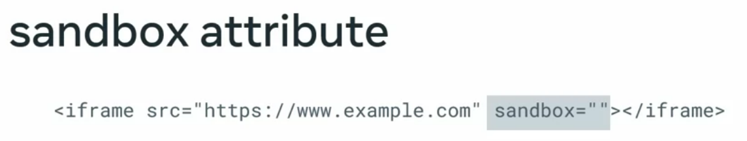

When the sandbox attribute is used with an empty value, all sandbox restrictions will apply to the iframe.

*You are a developer at the Little Lemon Tree company and your team leader has asked you to embed a map in the web page you are developing. You have learned that there are various important security issues when using iframes. Select the ways that these issues can be addressed. Check all that apply.*

* *Recommend that iframes are not used.*
* *You can use the allow attribute to limit which browser features the iframe can access.*
* *The sandbox attribute can prevent files from being downloaded.*

## iFrame as a picture

*A small business is planning to embed advertisements on their website and you have to create an iframe to set up an image on their website. However, there are some security concerns when it comes to embedded content. What can you do to minimize those concerns? Select all that apply.*

* *Add the sandbox attribute to the iframe element.*
* *Use the allow attribute.*

## The canvas element

Web G L is a popular technology for building two D and three D animations and advanced graphics. The benefit of WebGL is that a dedicated chip in your device called a graphics processing unit? Or GPU does the calculations when graphics are rendered to the screen. This allows for complex calculations such as lighting simulation and rendering massive three D worlds. It is important to note that while WebGL will always use the GPU, it's not guaranteed that the two D canvas will use the GPU. This will depend on the web browser implementation. WebGL is a complex technology and requires a lot of background information so for now let's focus on the canvas element.

*There are three main technologies underpinning the production of animated and video game content for the web browser. These are GIF or webP, 2D Canvas and WebGL. Which of the following statements about these technologies are true? Choose all that apply.*

* *2D Canvas is used for building both 2D video games and animations.*
* *GIF and webP are used to animate images, but with no interactivity.*